Class of 2003
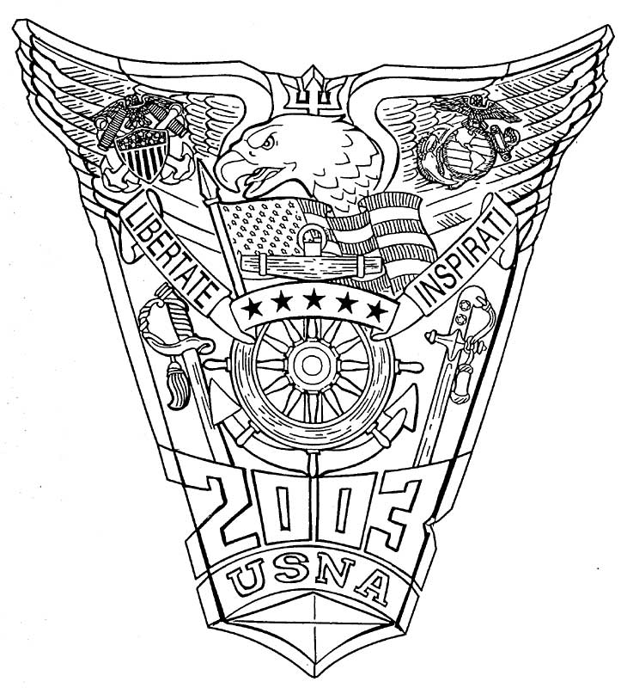

Briefing Notes (In the Works)

The Class of 2003 entered the United States Naval Academy in 1999. A total of 1245 entered with the class.
Graduation date 23 May 2003 with a total of 988 graduates:

789 Ensigns, Unrestricted Line, US Navy Reserves
8 Restricted Line, US Navy Reserves
6 Supply, Navy Reserves
2 Civil Engineer, Navy Reserves
5 Medical School
165 Marine Corps
2 Air Force Reserves
Total Commissioned: 977

8 Foreign Nationals:
1 Cameroon
1 Estonia
1 Philippines
2 Korea
1 Singapore
2 Thailand

3 Graduated, but not commissioned.

Attrition rate: 19.87%

Events around the Yard while 2003 was at USNA

1999 March - USNA undertakes strategic plan to move beyond the year 2010.
Sampson and Mahan Halls and the first wing of Bancroft Hall begin extensive renovations.
October - The Naval Academy and the Naval Academy Alumni Association hold the first Annual Distinguished Graduates Award dinner to honor Admiral Thomas H. Moorer ‘33, USN (Ret.)
4 December - Navy wins the 100th Army/Navy football game with a score of 19-9.

2000 21-October Second Annual Distinguished Graduates Award dinner honored Dr. John J. McMullen ‘40; Admiral James L. Holloway III ’43, USN (Ret.); Vice Admiral William P. Lawrence ’51, USN (Ret.);
Major General William A. Anders ’55, USNAFR (Ret.); and Mr. Roger Staubach ’65.
19-November- Dyer Tennis Clubhouse dedicated in memory of Vice Admiral George C. Dyer ’19, USN (Ret.)
2001 June- U.S. Naval Academy Foundation launches a $175-million comprehensive campaign, Leaders to Serve the Nation.

2001 11 September – Academy loses 14 Alumni in terrorist attacks on the World Trade Center and Pentagon and is placed under unprecedented high security.
22 September – Distinguished Graduates Award dinner recognizes
Captain John W. Crawford Jr. ’42, USN (Ret.); Captain William J. Crowe Jr. ’47, USN (Ret.); Vice Admiral James B. Stockdale ’47, USN (Ret.);
Admiral James D. Watkins ’49, USN (Ret.); and Captain James A. Lovell Jr. ’52 USN (Ret.)
November- Glenn Warner Soccer Facility dedicated in memory of the 30 -year head soccer Coach, Glenn Warner.
This is the first facility to be fully funded with private gifts as part of the USNA Campaign: Leaders to Serve the Nation.

2002 11 January- Colonel John R. Allen ’76, USMC is selected to become the 79th Commandant of Midshipmen, the first Marine Corps Officer to hold this position.
12- October- Distinguished Graduates Award dinner recognizes Vice Admiral Charles S. Minter Jr. ’37, USN (Ret.); President James E. Carter ’47; Admiral Carlisle A.H. Trost ’53, USN (Ret.); and Colonel John W. Ripley ’62, USMC (Ret.)
7 June – Vice Admiral Richard J. Naughton ’68, USN becomes 57th Superintendent.

2003 March – Distinguished Graduates Award Dinner recognizes Ambassador William H. G. FitzGerald 1931; Rear Admiral Eugene B. Fluckey 1935, USN (Ret.); Rear Admiral Robert W. McNitt 1938, USN (Ret.); and Vice Admiral William D. Houser 1942, USN (Ret.)
15 May – a ribbon cutting ceremony is held to mark the completion of renovation of the center section of Bancroft Hall that includes the Rotunda, Smoke Hall, Memorial Hall, and “catacombs” on Deck 4. This also celebrates the completion of the 10-year, $250 million renovation and modernization of Bancroft Hall, marking the first major reconstruction in almost 40 years.
May – The Naval Academy Company, Marine Barracks, Washington, start moving into a building on the Naval Academy grounds, which will serve as the Marine Quarterdeck, the command center for this company. The building will be named for Major General Ben Fuller, the 15th commandant of the Marine Corps, who is buried in the Naval Academy cemetery. The company’s barracks and mess hall will remain at the Naval Station.
5 June – Vice Admiral Charles W. Moore 1968, USN, becomes Acting Superintendent (58th)
The first Distinguished Military Professor in Leadership, funded through the family foundation of Bruce Lakefield 1967 and wife, Bernadine, is Colonel Arthur J. Athens, USMCR, USNA 1978.
2 August – Vice Admiral Rodney Rempt 1966, USN becomes 59th Superintendent.
18 September – Hurricane Isabel strikes the Chesapeake Bay area. Many Academy buildings are flooded.
2 November – Groundbreaking held for the Commodore Uriah P. Levy Center and Jewish Chapel, which will be built adjacent to Mitscher Hall, with funds raised in a collaborative effort led by the Friends of the Jewish Chapel and assisted by the U.S. Naval Academy Foundation. The new facility will house a fellowship hall, classrooms, offices, lounges, a media center, and the Academy’s Honor Court in the south wing, with the north wing housing the 410-seat Jewish Chapel.
31 December – Whiting-Turner Contracting Co. of Baltimore is awarded a $30.2 million contract to renovate Chauvenent Hall. Renovations completed in June 2005.

Superintendents:
VADM John R. Ryan ‘67
VADM Richard J. Naughton ‘68

Flags and Notables:

1 Rhodes Scholar: Kin Leong Ho, 2003

5 Olmsted Scholars: Timothy Gallagher, Eric Hui, Sean Wolfe, Edward Holton, Douglas Shores

2 Fitzgerald Scholars: Nathan A. Fleischaker, and Justin P. Accomando

1 White House Fellow: Matthew Phillips, 2017 - 2018

Class Gifts/Giving:
1. Since graduation, the Class of 2003 has donated over $300K to various causes around the Yard.
2. One Class Project has been funded:
- International Education Excellence support

Class Officers:

President: LtCol Lisa D. Cordonnier, USMC
Vice President: CDR Fernando R. Reyes, USN
Secretary: Mrs. Heather M. Selig
Treasurer: CDR Megan Barnett, USN
Shipmate Contact: Mr. Kenneth E. Michel

